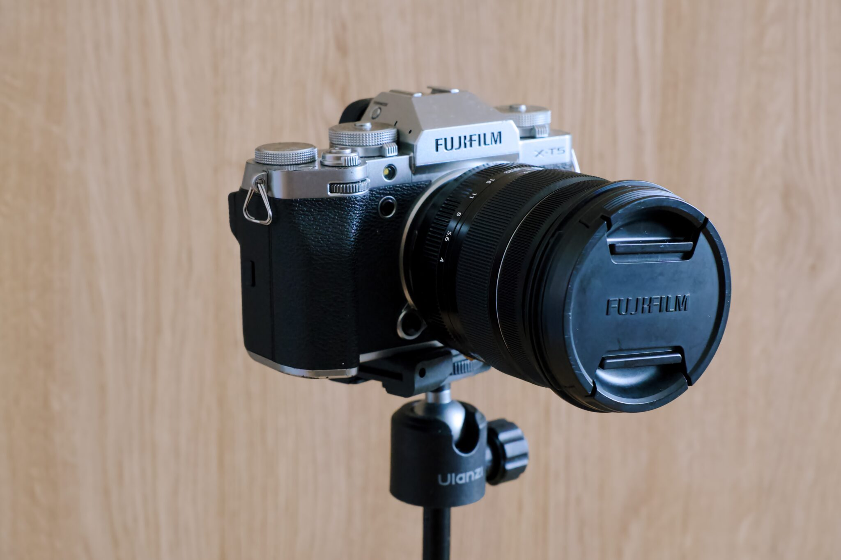

Fujifilm X-T5 Mirrorless Camera
The Fujifilm X-T5 is a premium APS-C mirrorless camera designed for professional photographers, content creators, and photography enthusiasts. It combines a classic retro design with the latest imaging technology, making it an excellent choice for landscape, portrait, wildlife, travel, and street photography. The camera is lightweight, durable, and weather-resistant, making it suitable for both indoor studio work and outdoor adventures.
The X-T5 is equipped with a 40.2-megapixel APS-C X-Trans CMOS 5 HR sensor, delivering outstanding image quality with exceptional detail, rich colors, and excellent dynamic range. It is powered by the X-Processor 5, which provides faster image processing, improved autofocus performance, reduced noise, and enhanced video recording capabilities.
One of the camera's strongest features is its 5-axis In-Body Image Stabilization (IBIS) system, offering up to 7 stops of stabilization. This allows photographers to capture sharp handheld images even in low-light conditions and record smooth, stable videos without requiring a tripod.
The Fujifilm X-T5 supports 6.2K video recording at 30fps and 4K recording up to 60fps, making it ideal for professional videography, YouTube content creation, documentaries, and filmmaking. It also includes advanced autofocus with AI-based subject detection that can recognize humans, animals, birds, vehicles, motorcycles, trains, and airplanes.
Its 3.69-million-dot OLED electronic viewfinder (EVF) provides a bright and detailed preview of the scene, while the 3-inch tilting touchscreen LCD offers flexible shooting angles for photography and videography. Dual UHS-II SD card slots provide reliable storage options for professionals who require backup recording or additional storage capacity.
The camera features built-in Wi-Fi and Bluetooth, allowing users to transfer photos wirelessly to smartphones, control the camera remotely, and instantly share images on social media. With its long battery life, compact body, weather-resistant construction, and famous Fujifilm Film Simulation modes, the X-T5 delivers an exceptional shooting experience.

Key Features
- Camera Type: Mirrorless Digital Camera
- Sensor: 40.2 MP APS-C X-Trans CMOS 5 HR
- Processor: X-Processor 5
- Image Stabilization: 5-Axis In-Body Image Stabilization (IBIS)
- Video Recording: 6.2K at 30fps, 4K at 60fps, Full HD up to 240fps
- Autofocus: AI Subject Detection with Face & Eye Detection
- Continuous Shooting: Up to 20 fps (Electronic Shutter)
- Viewfinder: 3.69M-dot OLED Electronic Viewfinder
- LCD Screen: 3-inch Tilting Touchscreen
- Storage: Dual UHS-II SD Card Slots
- Connectivity: Wi-Fi, Bluetooth, USB-C, HDMI
- Battery: NP-W235 Rechargeable Battery
- Weather Resistance: Dust and Moisture Resistant Body
- Weight: Approximately 557 g (with battery and memory card)

Advantages
- Ultra-high 40.2 MP image resolution
- Professional image quality with vibrant Fujifilm colors
- Excellent low-light performance
- Advanced AI autofocus system
- Powerful 5-axis image stabilization
- High-quality 6.2K and 4K video recording
- Compact, lightweight, and travel-friendly design
- Durable weather-sealed body
- Dual memory card slots for professional workflows
- Wireless image sharing and remote camera control

Applications
The Fujifilm X-T5 is ideal for:
- Professional Photography
- Portrait Photography
- Landscape Photography
- Wildlife Photography
- Street Photography
- Wedding Photography
- Travel Photography
- Sports Photography
- YouTube Content Creation
- Professional Videography
- Documentary Filmmaking

